Review article

Holography

Yoon Jegal

**1. Introduction**

Holography is a technic to make a hologram, which is a Three-dimensional (3D) image and invented in 1948 by Denis Gabor [1]. Holography can be made by manipulating amplitude and phase. To manipulate them, we use Spatial light modulators (SLM). Recent SLM’s pixel sizes are a few micro meters. They are smaller than visible light’s wavelength, so they can’t represent all information for Three-dimensional (3D) information thus noise and viewing angle problems appear. Metamaterial[2-4], is a sub-wavelength scale material and can manipulate amplitude and phase [9-14]. This review focuses on plasmonic, dielectric and active metasurfaces for holography.

**2. manipulate phase and amplitude**

2.1 plasmonic metasurface

A surface plasmons(SPs) is a collective oscillation of electrons. It can propagate along the boundary between metal and dielectric and then it is called as a surface plasmon polaritons(SPPs). It is a highly localized electromagnetic fields, so they can manipulate photons on subwavelength scale [5-8]. Using Plasmonic antenna [9,15-18] can be made. When incident electromagnetic wave impinges antenna, it suffer phase and amplitude changes. Fig 1 is calculated by analytically solving Hallen’s integral equations for linear antenna with length L and radius a = L/50. when small antenna (L/ $λ_{0}$ <<1) the charges in the antenna instantaneously follows the incident filed, $\tilde{q}∝{\tilde{E}}_{inc}=E_{inc}exp⁡(iwt)$ where $\tilde{q}$ is the accumulated charges at one end of the antenna. The emitted light, which is proportion to the acceleration of the charges [20] is ${\tilde{E}}_{scat}∝\frac{∂^{2}\tilde{q}}{∂t^{2}}∝-w^{2}{\tilde{E}}_{inc}$. Clearly, incident and scattered light have $π$ phase difference. At resonance (L/ $λ_{0}=1/2)$, the incident field in in phase with the current at the center of the antenna $\tilde{I}∝{\tilde{E}}_{inc}$ and ${\tilde{E}}_{scat}∝\frac{∂^{2}\tilde{q}}{∂t^{2}}∝iw{\tilde{E}}_{inc}$. Clearly $π/2$ phase difference. When antenna length is same with wavelength (L/ $λ_{0}=1)$, antenna impedance is primarily inductive, $\tilde{I}∝{-i\tilde{E}}_{inc}$ ${\tilde{E}}_{scat}∝\frac{∂^{2}\tilde{q}}{∂t^{2}}∝{\tilde{E}}_{inc}$.

Clearly, both waves are in phase.[9] As you can see fig. 1, plasmonic antenna can only make $π$ phase delay. For full control of phase, we need 2 $π$ phase coverage, so use the polarization. Also, amplitude must be same, so adding freedoms to antenna is essential. Yu [9] made V shape antenna with same amplitude and $π$/4 phase difference each antenna. Fig 2 show that freedom at length (h) and degree (△) of antenna make same amplitude but different phase.

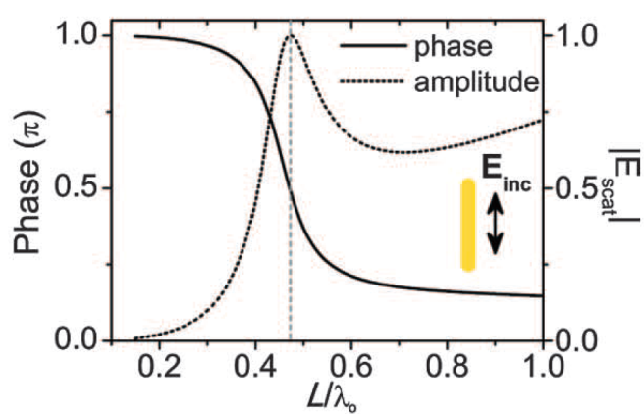

**Fig. 1** calculated phase and amplitude of scattered field with length L and radius a = L/50. [9]

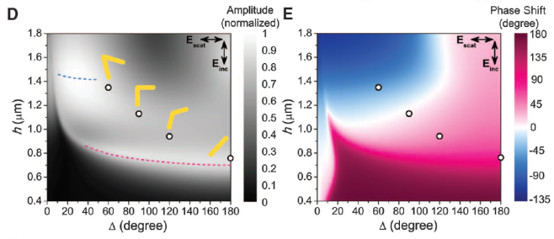

**Fig. 2** changing amplitude and phase by different degree(△) and length(h). [9]

Using linearly polarized light and mirror structure, 8 metasurfaces, which are equal amplitude and incremental phase of $\frac{π}{4}$ are made. Fig. 3 shows the metasurfaces. By the fig. 4, the generalized laws of reflection and refraction can be derived and if metasurfaces are set along y axis the 3D generalized laws of reflection and refraction is [11]

$n_{t}\sin\left(θ_{t}\right)-n_{i}\sin\left(θ_{i}\right)=\frac{1}{k_{0}}\frac{dΦ}{dx}$ Generalized law

cos( $θ_{t})\sin\left(φ_{t}\right)=\frac{1}{n_{t}k_{0}}\frac{dΦ}{dy}$ of refraction

$\sin\left(θ_{r}\right)-\sin\left(θ_{i}\right)=\frac{1}{{n_{i}k}_{0}}\frac{dΦ}{dx}$ Generalized law

cos( $θ_{r})\sin\left(φ_{r}\right)=\frac{1}{n_{r}k_{0}}\frac{dΦ}{dy}$ of reflection

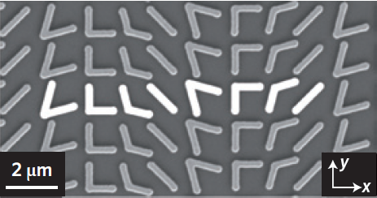

**Fig. 3** metasurfaces which are equal amplitude and incremental phase of $\frac{π}{4}$ [11]

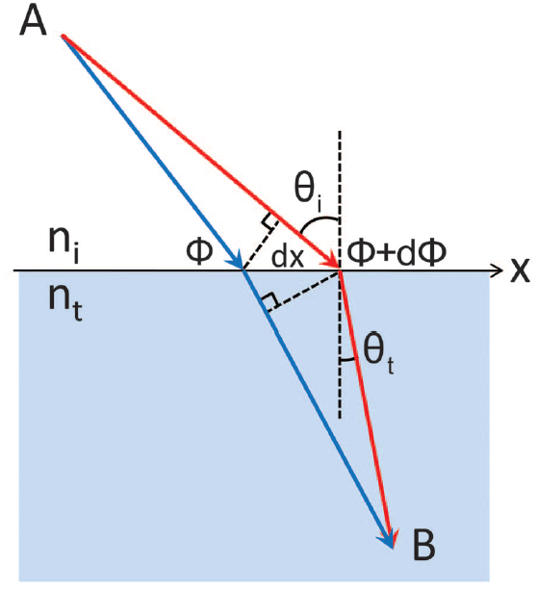

**Fig. 4** metasurfaces are set between the two media with same amplitude but incremental phase along x.[9]

[9] metasurface uses metal, so it makes absorption loss. So, nowadays metasurface researches focus on dielectric metasurfaces.

2.2 Pancharatnam-Berry phase

Geometric phase, Pancharatnam-Berry phase or most commonly Berry phase is a phase difference acquired over the course of a cycle. In other words, right circular polarized (RCP) and left circular polarized(LCP) waves suffer different phase delay. Polarizer for jones matrix is [19]

$$M_{pol}=\left(\begin{matrix}cos^{2}θ & sinθcosθ \\ sinθcosθ & sin^{2}θ\end{matrix}\right)$$

When incident circularly polarized wave $E_{I}^{R/L}$ transmit polarizer, transmitted light is

$E_{T}^{R/L}=M_{pol}∙E_{I}^{R/L}$ = $\left(\begin{matrix}cos^{2}θ & sinθcosθ \\ sinθcosθ & sin^{2}θ\end{matrix}\right)\left(\begin{matrix}1 \\ ∓i\end{matrix}\right)$

=exp($∓iθ) \left(\begin{matrix}cosθ \\ sin⁡θ\end{matrix}\right)$

Clearly, RCP and LCP have a phase difference 2 $θ.$ [13] is berry phase metasurface for holography. they used poly-si and made x shaped metasurfaces.

[1] Gabor D. A new microscopic principle. Nature 1948;161:777–8.

[2] Pendry, J. B., Schurig, D. & Smith, D. R. Controlling electromagnetic fields. *Science* **312,** 1780–1782 (2006).

[3] Leonhardt, U. Optical conformal mapping. *Science* **312,** 1777–1780 (2006).

[4] Cai, W. & Shalaev, V. *Optical Metamaterials: Fundamentals and Applications* (Springer, 2009).

[5] Barnes, W. L., Dereux, A. & Ebbesen, T. W. Surface plasmon subwavelength optics. Nature 424, 824–830 (2003).

[6] Maier, S. A. et al. Local detection of electromagnetic energy transport below the diffraction limit in metal nanoparticle plasmon waveguides. Nature Mater. 2,

229–232 (2003).

[7] Gramotnev, D. K.; Bozhevolnyi, S. I. Plasmonics beyond the diffraction limit Nat. Photonics 2010, 4, 83.

[8] Maier, S. Plasmonics: Fundamentals and Applications; Springer: New York, 2007.

[9] Yu, N. *et al.* Light propagation with phase discontinuities: Generalized laws of reflection and refraction. *Science* **334,** 333–337 (2011).

[10] Aieta, F. *et al.* Out‑of‑plane reflection and refraction of light by anisotropic optical antenna metasurfaces with phase discontinuities. *Nano Lett.* **12,** 1702–1706 (2012).

[11] N. Yu, F. Capasso, Flat optics with designer metasurfaces.

Nat. Mater. 13, 139–150 (2014).

[12] Kildishev, A. V., Boltasseva, A. & Shalaev, V. M. Planar photonics with metasurfaces. *Science* **339,** 1232009 (2013).

[13] G.Y. Lee, G. Yoon, S.Y. Lee, H. Yun, J. Cho, K. Lee, H. Kim, J. Rho, B. Lee,

Complete amplitude and phase control of light using broadband holographic metasurfaces. Nanoscale (2018).

[14] M. Decker et al., High‐efficiency dielectric Huygens’ surfaces.

Adv. Opt. Mater. 3, 813–820 (2015).

Schurig, D. *et al.* Metamaterial electromagnetic cloak at microwave frequencies. *Science* **314,** 977–980 (2006).

[15] L. Novotny, N. Van Hulst, Antennas for light. Nat. Photonics 5,83–90 (2011). doi: 10.1038/nphoton.2010.237

[16] Novotny, L. Effective wavelength scaling for optical antennas. *Phys*. *Rev*. *Lett*.**98,** 266802 (2007).

[17] M. Sukharev, J. Sung, K. G. Spears, T. Seideman,

Phys. Rev. B 76, 184302 (2007)

[18] P. Biagioni, J. S. Huang, L. Duò, M. Finazzi, B. Hecht,

Phys. Rev. Lett. 102, 256801 (2009).

[19] B. E. Saleh and M. C. Teich, Fundamentals of Photonics, 2nd ed. (Wiley-Interscience, New York, 2007).

[20] Jackson, J. D. Classical Electrodynamics; Wiley: New York, 1999